

Principles of Machine Learning

Lab 2 – Regression

# Overview

In this lab, you will train and evaluate a regression model. Like classification, regression is a supervised machine learning technique in which a set of data with known labels is used to train and test a model. Whereas classification predicts whether or not a label falls into one class or another, regression predicts a real numeric value for the label.

In this lab you will use the data set provided to predict the demand in a bicycle rental system. The steps in this process include:

* Explore the data set.
* Create a linear regression model.
* Evaluate the model using both computed metrics and visualization.

# What You’ll Need

To complete this lab, you will need the following:

* An Azure ML account
* A web browser and Internet connection
* The lab files for this lab

**Note**: To set up the required environment for the lab, follow the instructions in the [Setup Guide](https://aka.ms/edx-dat203.2x-setup) for this course.

# Exploring the Data

In this lab you will work with a dataset that contains records of bike rentals.

## Visualize the Source Data

The bike rentals data set is provided as a sample data set in Azure Machine Learning.

1. If you have not already done so, open a browser and browse to <https://studio.azureml.net>. Then sign in using the Microsoft account associated with your Azure ML account.
2. Create a new blank experiment, and give it the title **Bike Regression**.
3. In the list of experiment items, expand **Saved Datasets** and **Samples**, and then drag **Bike Rental UCI dataset** to the experiment canvas.
4. Visualize the output of the dataset and review the columns it contains. Note that these include various columns containing temporal and meteorological information for each hour, starting at 00:00 on January 1st 2011. Additionally, the dataset includes the hourly count of bike rentals by **casual** and **registered** customers, with the total hourly rentals recorded in the **cnt** column.

Your goal with this dataset is to create a regression model that uses the temporal and meteorological features to accurately predict the **cnt** label for each hour.

## Cleanse the Data

The data requires some cleansing before you can explore it and use it in a regression model. You will do this using a combination of built-in Azure ML modules and custom script, which you can implement in R or Python. Follow the steps for your preferred language below.

### Cleanse the Data Using R

1. Add an **Execute R Script** module to the experiment and place it alongside the bike rental dataset. Then select the **Execute R Script** module and in the **Properties** pane, replace the default script with the following code (which you can copy and paste from **SetDayOfWeek.R** in the folder where you extracted the lab files for this module):

set.day.of.week <- function(){

library(dplyr)

## First day in the dataset is Saturday

data.frame(weekday= c(0, 1, 2, 3, 4, 5, 6),

dayOfWeek = c("Sun", "Mon", "Tue", "Wed", "Thr", "Fri", "Sat"),

stringsAsFactors = FALSE)

}

df <- set.day.of.week()

maml.mapOutputPort('df')

This code creates a data frame that contains the numeric days of the week (0 to 7) and their equivalent names (Sun to Sat)

1. Add a **Join Data** module to the experiment and place it below the dataset and **Execute R Script** module. Then connect the output from the dataset to the left input of the **Join Data** module, and connect the left output of the **Execute R Script** module to the right input of the **Join Data** module as shown here:

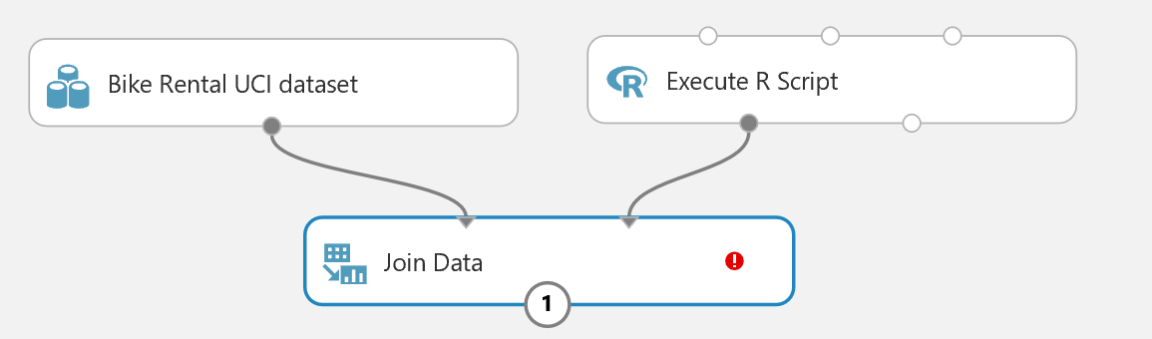

1. Select the **Join Data** module and in the properties pane, set the following properties:
   * **Join key columns for L**: Select the **weekday** column.
   * **Join key columns for R**: Start with no columns and include **weekday** (you will need to type this).
   * **Match case**: Selected
   * **Join type**: Left Outer Join
   * **Keep right key columns in joined table**: Not selected
2. Add a second **Execute R Script** module to the experiment, below the **Join Data** module; and connect the output from the **Join Data** module to its left-most input.
3. Select the **Execute R Script** module you just added, and replace its default script with the following code (which you can copy and paste from **SetDays.R**):

set.days <- function(df){

df[,'days'] = as.integer(df[, 'instant']/24)

df

}

df <- maml.mapInputPort(1)

df <- set.days(df)

maml.mapOutputPort('df')

This code adds a column named **days** that contains an integer value indicating the elapsed days from the first record in the dataset.

1. Save and run the experiment, and then visualize the **Results dataset** (left) output of the **Execute R Script** module to verify that the **days** column has been added.
2. Add a **Select Columns in Dataset** module to the experiment, under the most recently added **Execute R Script** module, and connect the left output of the **Execute R Script** module to its input.
3. In the properties of the **Select Columns in Dataset** module, select all columns excluding the following ones:
   * instant
   * dteday
   * weekday
   * atemp
   * casual
   * registered
4. Add a **Normalize Data** module to the experiment, and connect the output of the **Select Columns in Dataset** module to its input and set its properties as follows:
   * **Transformation method**: ZScore
   * **Use 0 for constant columns when cached**: Unselected
   * **Selected columns**: temp, hum, and windspeed.
5. Verify that your experiment looks like this:

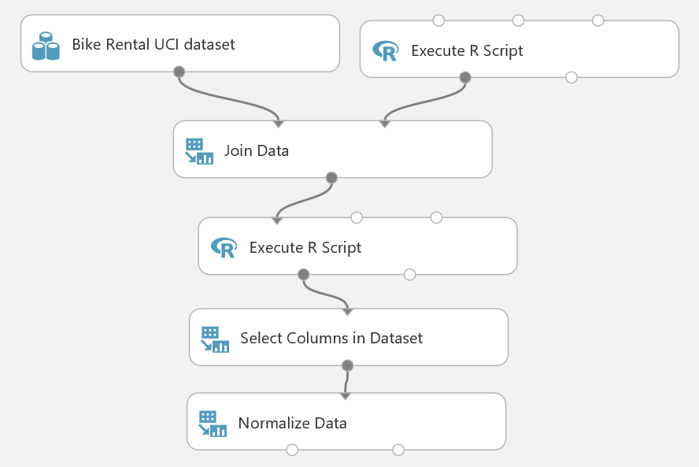

1. Save and run the experiment.

### Clean the Data using Python

1. Add an **Execute Python Script** module to the experiment and place it alongside the bike rental dataset. Then select the **Execute Python Script** module and in the **Properties** pane, replace the default script with the following code (which you can copy and paste from **SetDayOfWeek.py** in the folder where you extracted the lab files for this module):

def day_of_week():

import pandas as pd

## First day in the dataset is Saturday

days = pd.DataFrame([[0, 1, 2, 3, 4, 5, 6],

["Sun", "Mon", "Tue", "Wed", "Thr", "Fri", "Sat"]]).transpose()

days.columns = ['indx', 'dayOfWeek']

return days

def azureml_main():

return day_of_week()

This code creates a data frame that contains the numeric days of the week (0 to 7) and their equivalent names (Sun to Sat)

1. Add a **Join Data** module to the experiment and place it below the dataset and **Execute Python Script** module. Then connect the output from the dataset to the left input of the **Join Data** module, and connect the left output of the **Execute Python Script** module to the right input of the **Join Data** module as shown here:

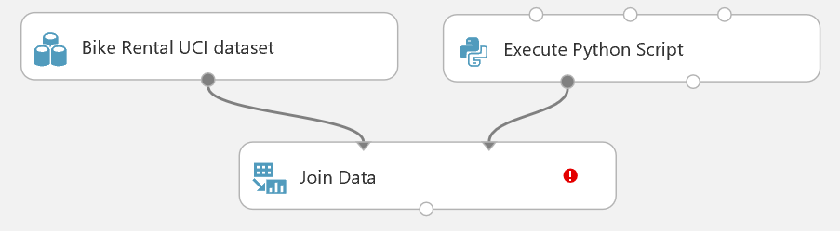

1. Select the **Join Data** module and in the properties pane, set the following properties:
   * **Join key columns for L**: Select the **weekday** column.
   * **Join key columns for R**: Start with no columns and include **weekday** (you will need to type this).
   * **Match case**: Selected
   * **Join type**: Left Outer Join
   * **Keep right key columns in joined table**: Not selected
2. Add a second **Execute Python Script** module to the experiment, below the **Join Data** module; and connect the output from the **Join Data** module to its left-most input.
3. Select the **Execute Python Script** module you just added, and replace its default script with the following code (which you can copy and paste from **SetDays.py**):

def set_days(df):

import pandas as pd

df['days'] = pd.Series(range(df.shape[0]))/24

df['days'] = df['days'].astype('int')

return df

def azureml_main(df):

return set_days(df)

This code adds a column named **days** that contains an integer value indicating the elapsed days from the first record in the dataset.

1. Save and run the experiment, and then visualize the **Results dataset** (left) output of the **Execute R Script** module to verify that the **days** column has been added.
2. Add a **Select Columns in Dataset** module to the experiment, under the most recently added **Execute Python Script** module, and connect the left output of the **Execute Python Script** module to its input.
3. In the properties of the **Select Columns in Dataset** module, select all columns excluding the following ones:
   * instant
   * dteday
   * weekday
   * atemp
   * casual
   * registered
4. Add a **Normalize Data** module to the experiment, and connect the output of the **Select Columns in Dataset** module to its input and set its properties as follows:
   * **Transformation method**: ZScore
   * **Use 0 for constant columns when cached**: Unselected
   * **Selected columns**: temp, hum, and windspeed.
5. Verify that your experiment looks like this:

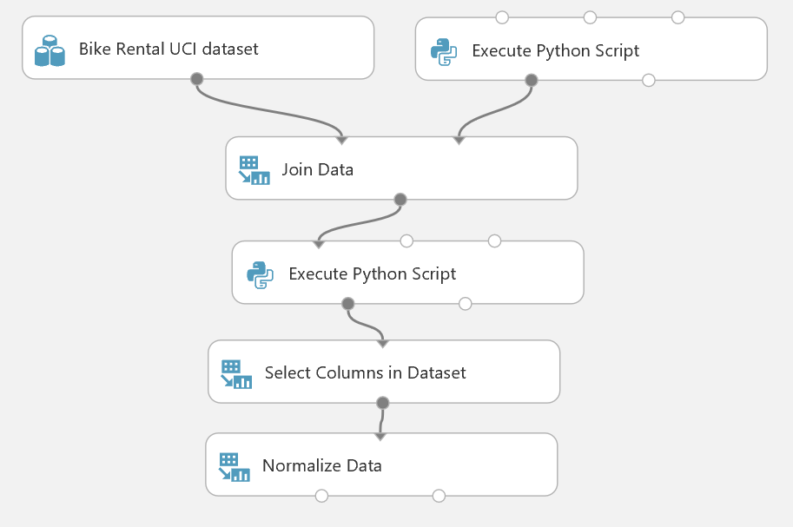

1. Save and run the experiment.

## Visualize the Data

Now that you have performed some initial data cleansing, you can explore the day visually and try to determine any relationship between the features in the dataset and the number of bike rentals. You can visualize the data using R or Python.

### Visualize the Data Using R

1. Add a **Convert to CSV** module to the experiment and connect the output of the **Normalize Data** module to its input. Then run the experiment.
2. Right-click the output of the **Convert to CSV** module and in the **Open in a new workbook** submenu, click **R**.
3. In the new browser tab that opens, at the top of the page, rename the new workbook **Bike Rental Visualization**.
4. Review the code that has been generated automatically. The code in the first cell loads a data frame from your experiment. The code in the second cell uses the **head** command to display the first few rows of data.
5. On the **Cell** menu, click **Run All** to run all of the cells in the notebook, and then view the output.
6. On the **Insert** menu, click **Insert Cell Below** to add a new cell to the notebook.
7. In the new cell, enter the following code (which you can copy and paste from **BikeVisualize.R**):

numCols <- c("temp", "hum", "windspeed", "hr")

bike.scatter <- function(df, cols){

require(ggplot2)

for(col in cols){

p1 <- ggplot(df, aes_string(x = col, y = "cnt")) +

geom_point(aes(alpha = 0.001, color = "blue")) +

geom_smooth(method = "loess") +

ggtitle(paste('Count of bikes rented vs. ', col)) +

theme(text = element_text(size=16))

print(p1)

}

}

catCols <- c('season', 'yr', 'mnth', 'hr', 'holiday', 'workingday', 'weathersit', 'dayOfWeek')

bike.box <- function(df, cols){

require(ggplot2)

for(col in cols){

p1 <- ggplot(df, aes_string(x = col, y = 'cnt', group = col)) +

geom_boxplot()+

ggtitle(paste('Count of bikes rented vs. ', col)) +

theme(text = element_text(size=16))

print(p1)

}

}

pltTimes = c(6, 8, 10, 12, 14, 16, 18, 20)

bike.series <- function(df, tms){

require(ggplot2)

ylims = c(min(df$cnt), max(df$cnt))

for(t in tms){

temp = df[df$hr == t, ]

p1 <- ggplot(temp, aes(x = days, y = cnt)) +

geom_line() +

ylim(ylims) +

ylab('Bikes rented') +

ggtitle(paste('Count of bikes rented vs. time for', t, 'hour of the day')) +

theme(text = element_text(size=16))

print(p1)

}

}

histCols <- c("temp", "hum", "windspeed", "cnt")

bike.hist <- function(df, cols){

require(ggplot2)

for(col in cols){

p1 <- ggplot(df, aes_string(x = col)) +

geom_histogram() +

ggtitle(paste('Density of', col)) +

theme(text = element_text(size=16))

print(p1)

}

}

bike.hist.cond <- function(df, tms){

require(ggplot2)

# require(gridExtra)

par(mfrow = c(2,4))

for(i in 1:length(tms)){

temp = df[df$hr == tms[i], ]

p <- ggplot(temp, aes(x = cnt)) +

geom_histogram() +

ggtitle(paste('Density of bike rentals at time', as.character(tms[i]))) +

theme(text = element_text(size=16))

print(p)

}

# grid.arrange(grobs = p, ncol = 3)

par(mfrow = c(1,1))

}

This code defines some functions that you will use to create plots of the data.

1. Ensure that the cursor is in the cell containing the function definitions above, and then on the **Cell** menu, click **Run and Select Below** (or click the ⯈ button on the toolbar).
2. After the code has finished running, in the new empty cell at the bottom of the notebook, enter the following code, and then run the new cell and wait for the code to finish running:

bike.scatter(dat, numCols)

**Tip**: The code may take a few minutes to run. While it is running, a⏺symbol is displayed at the top right under the R logo, and when the code had finished running this changes to a **O** symbol

1. View the plots that are produced.

**Tip**: Click the grey bar on the left edge of the output pane containing the plots to see all of the output in the main notebook window.

1. In the first two scatter plots (shown below), note that the number of bike rentals (**cnt**) rises as temperature (**temp**) rises. Conversely, bike rentals tend to drop as humidity (**hum**) rises.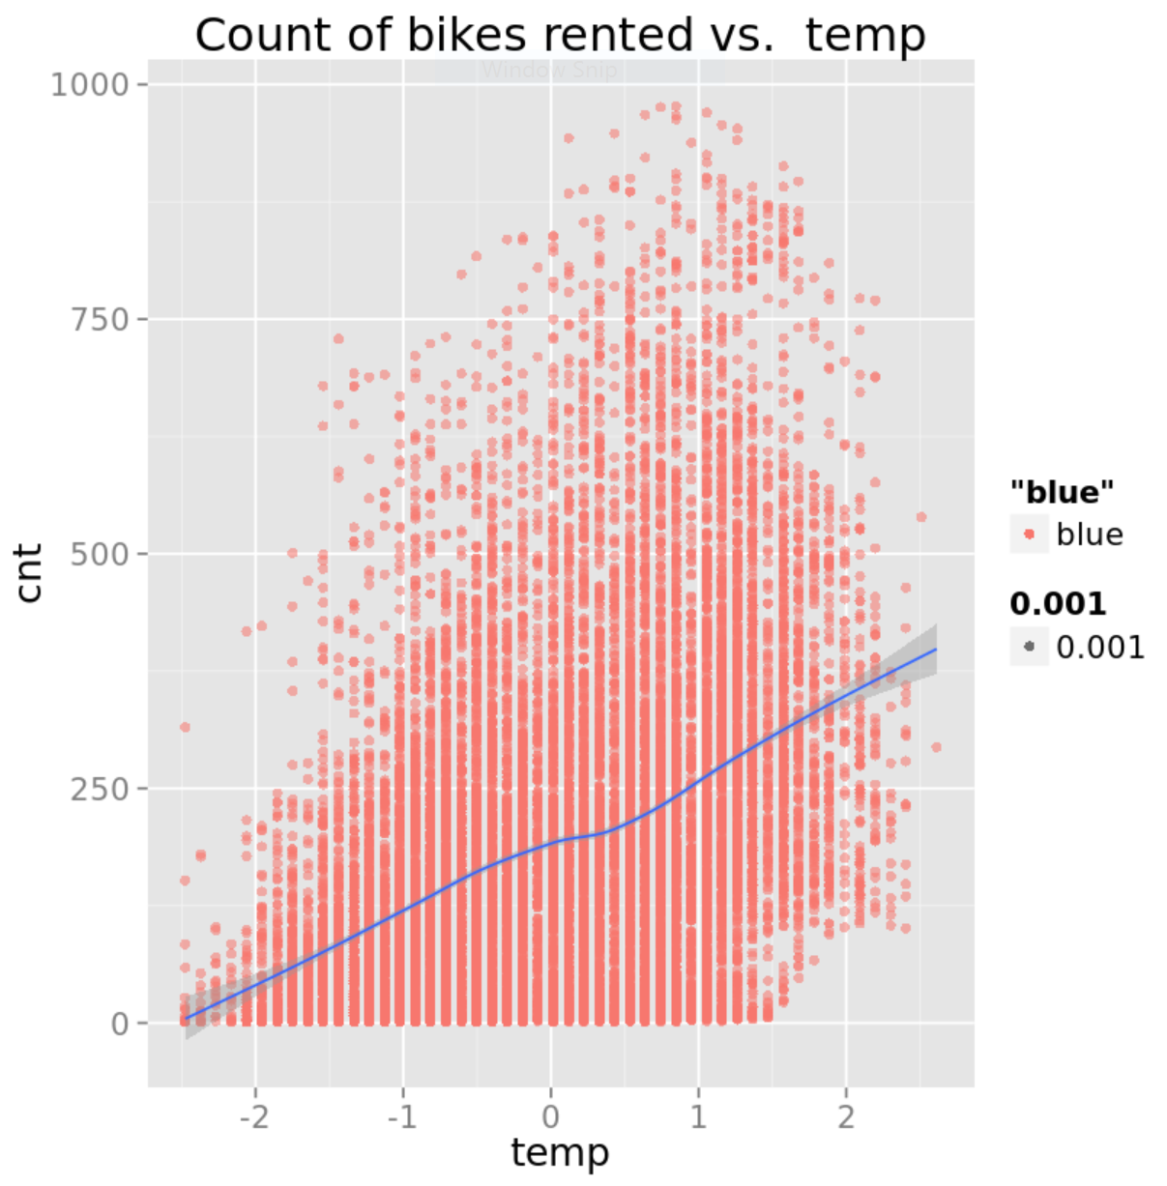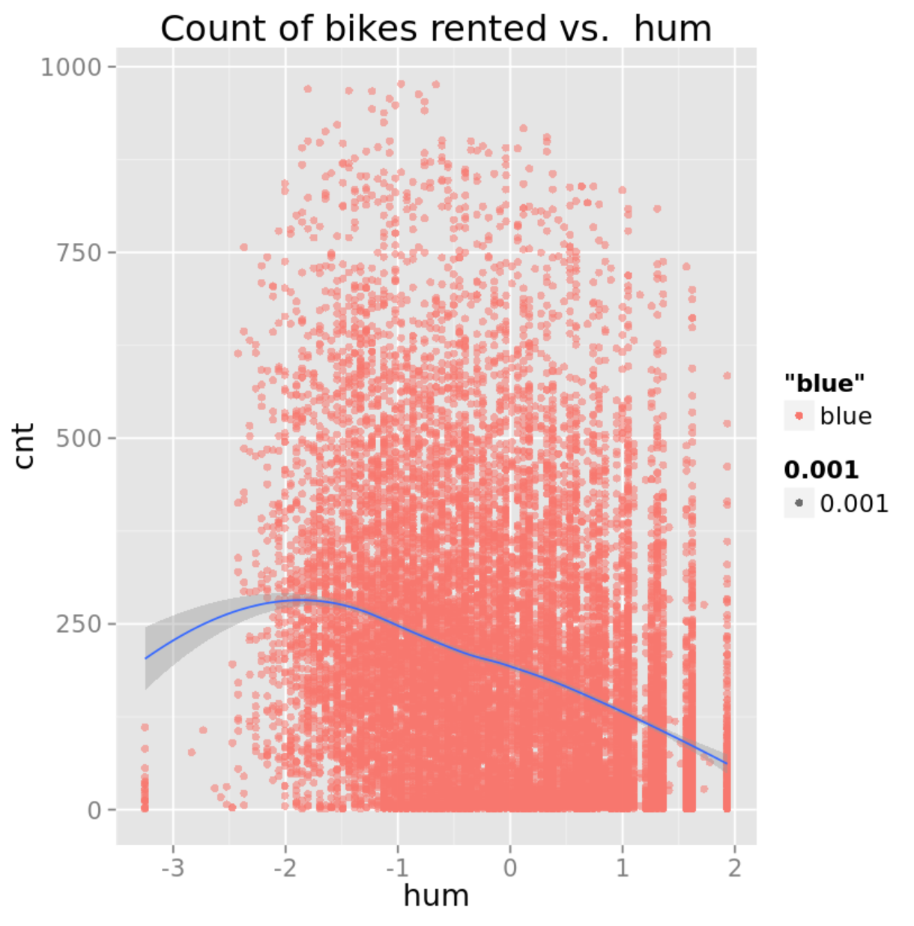
2. Review the other scatterplots, noting the apparent effect (or lack thereof) that the numeric features appear to have on the number of bike rentals.
3. In an empty cell at the bottom of the notebook, enter the following code, and then run the new cell and wait for the code to finish running:

bike.box(dat, catCols)

1. View the boxplots that are produced, which include the two boxplots shown below. Note that there are significant differences in bike rental demand by hour of the day (**hr**) – Most rentals occurring during commute hours, and very few rentals in the early hours of the morning. However, the day of the week (**dayOfWeek**) appears to make little difference to the number of bike rentals. Sunday has the lowest median, but the difference is well within the range of the middle two quartiles.

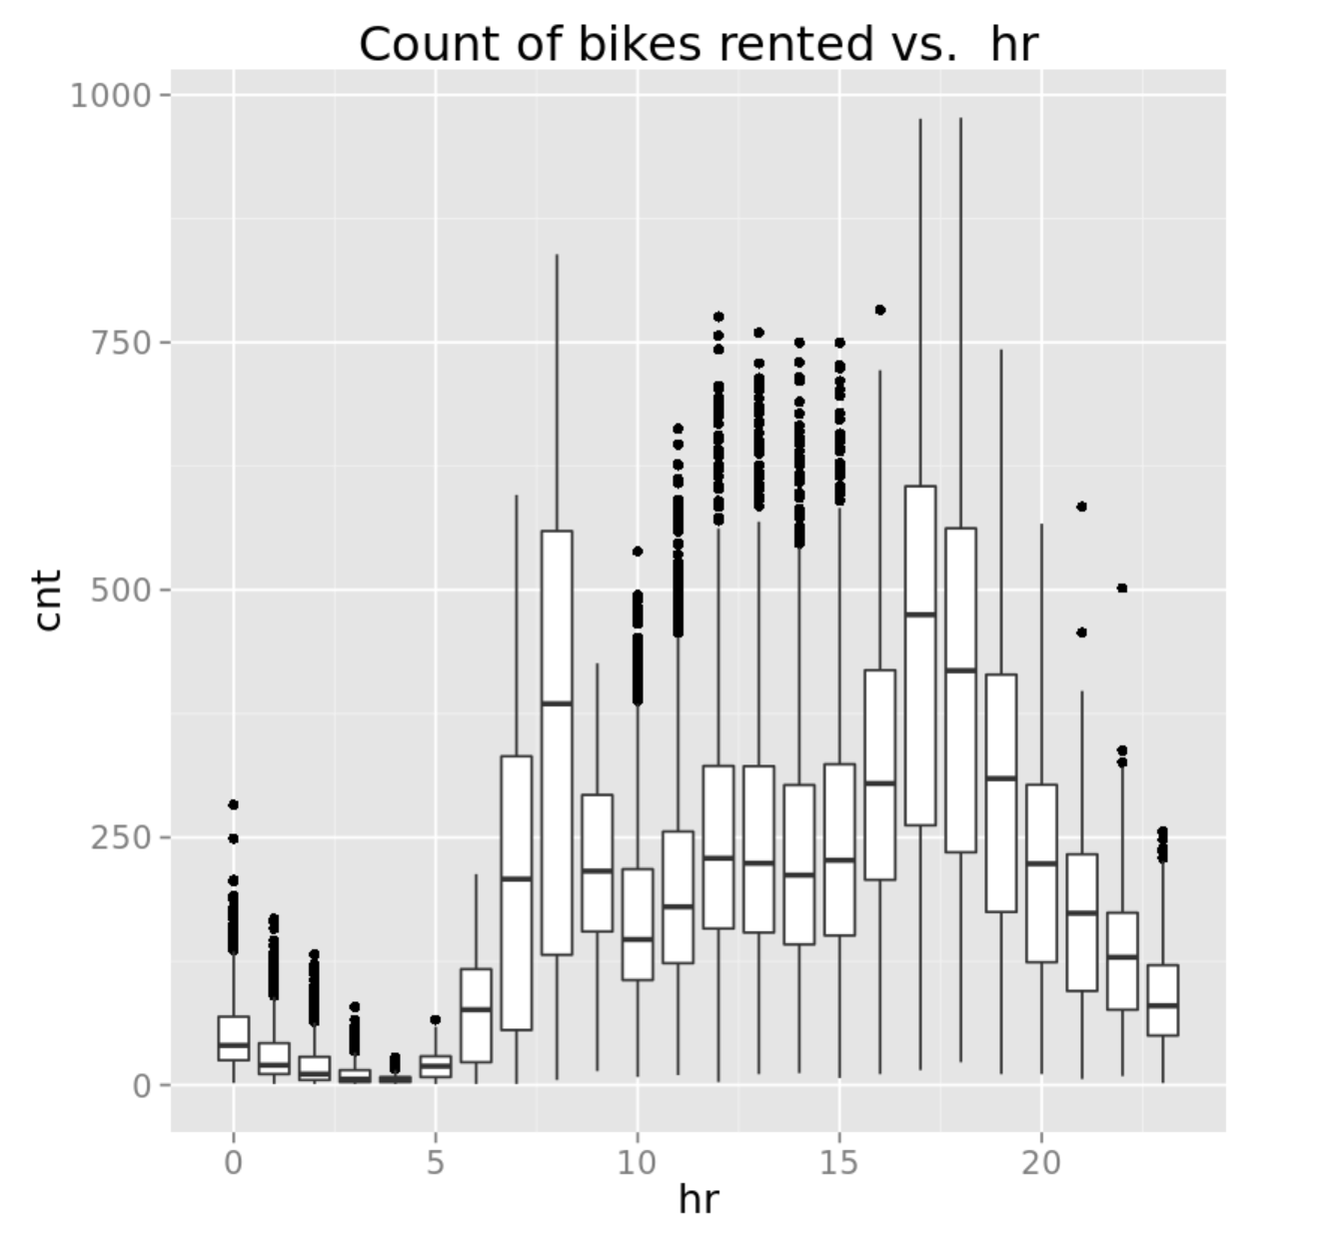

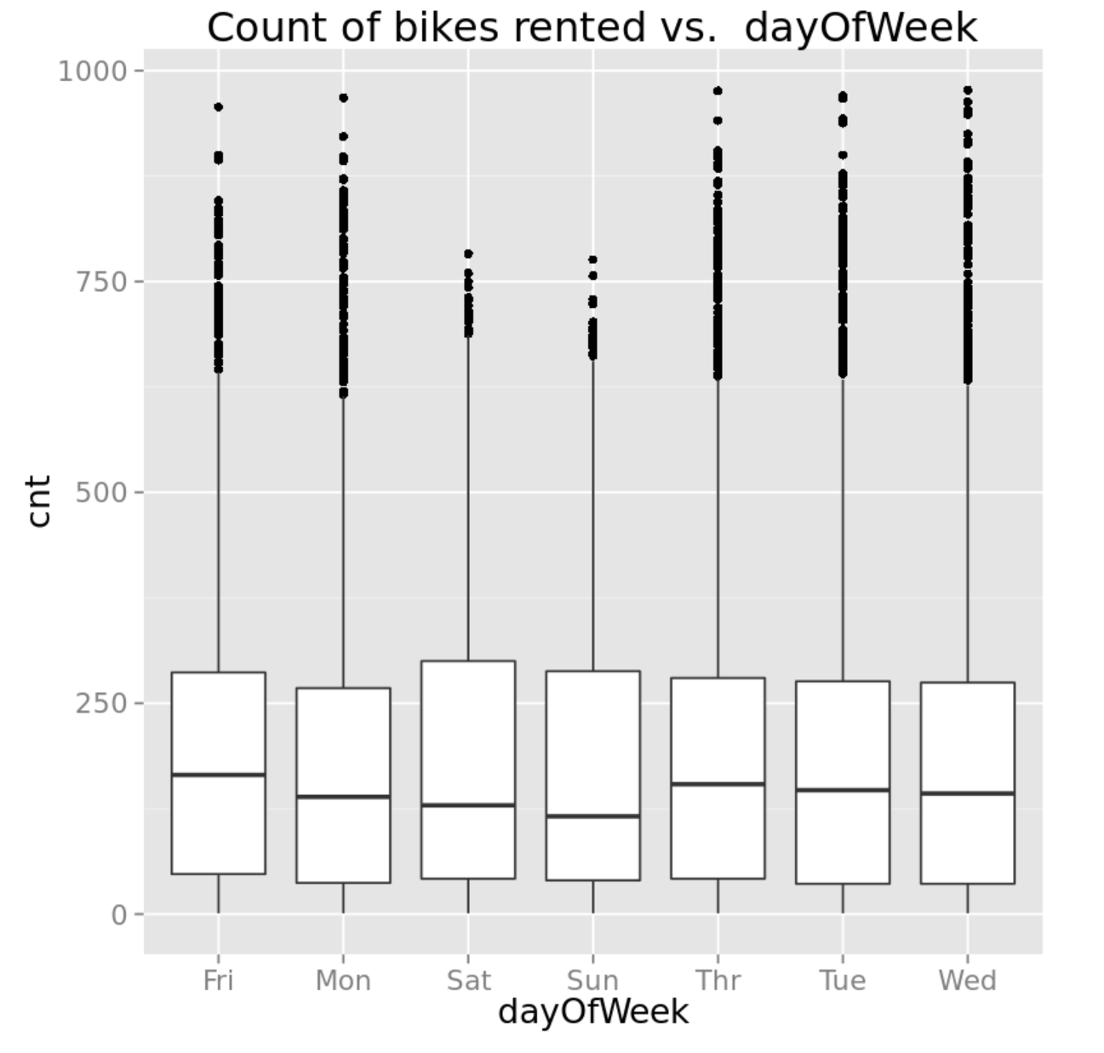

1. Review the other boxplots, noting the apparent effect (or lack thereof) that the categorical features appear to have on the number of bike rentals.
2. In an empty cell at the bottom of the notebook, enter the following code, and then run the new cell and wait for the code to finish running:

bike.series(dat, pltTimes)

1. View the line plots that are produced, which include the two plots shown below. Note that there is a general trend of increasing bike rentals over time (**days**) for all hours of the day, and that the number of rentals at certain hours (for example hour 6, which is 6:00am) is consistently lower than for other hours (for example hour 18, which is 6:00pm). Further, there is a strong seasonal effect, where bike demand is strongest in the warm summer months. The daily variation in bike demand by hour of the day results in the high-frequency behavior observed.

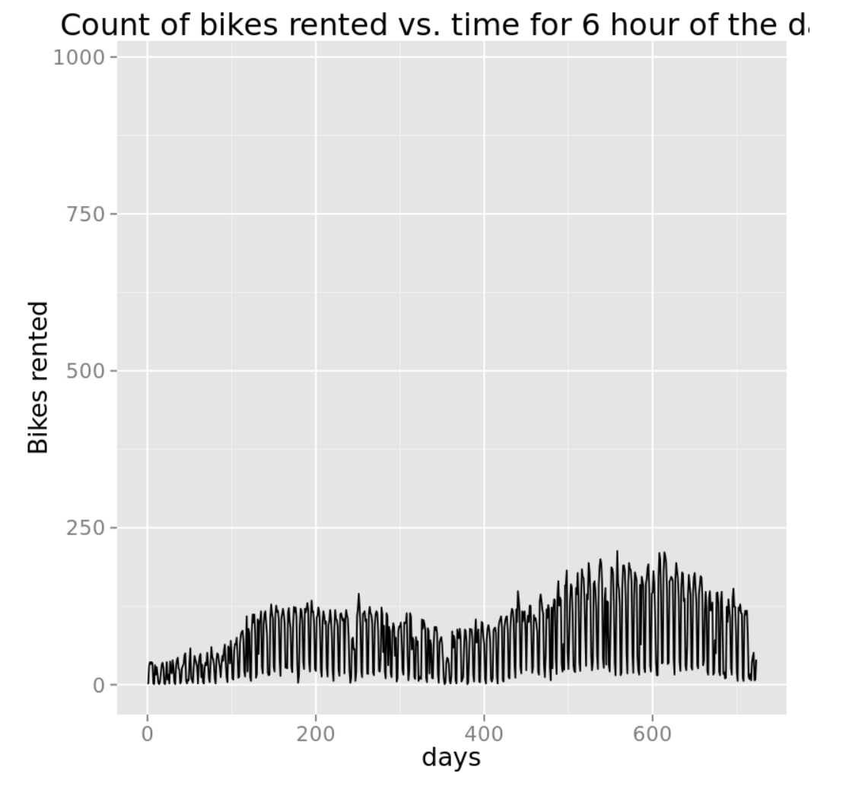

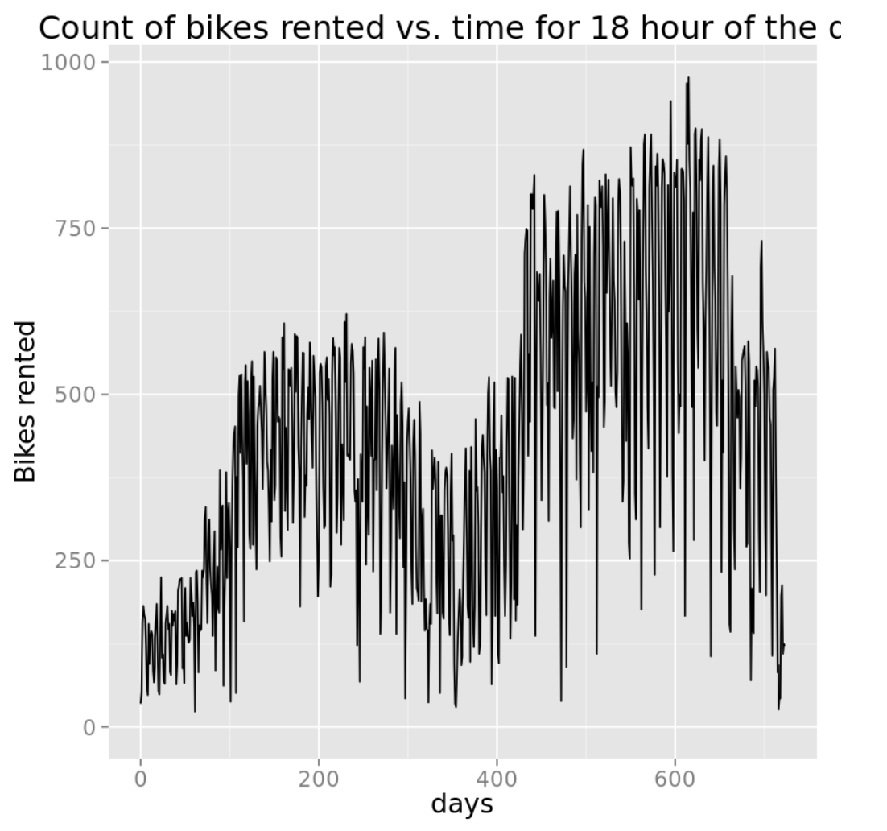

1. Review the other line plots, noting the trends for bike rentals at each hour of the day.
2. In an empty cell at the bottom of the notebook, enter the following code, and then run the new cell and wait for the code to finish running:

bike.hist(dat, histCols)

1. View the histograms that are produced, which include the plot shown below. Note that the normalized temperature values tend to most commonly be between -1 and +1, indicating that there are only a few occasions with extreme low or high temperatures.

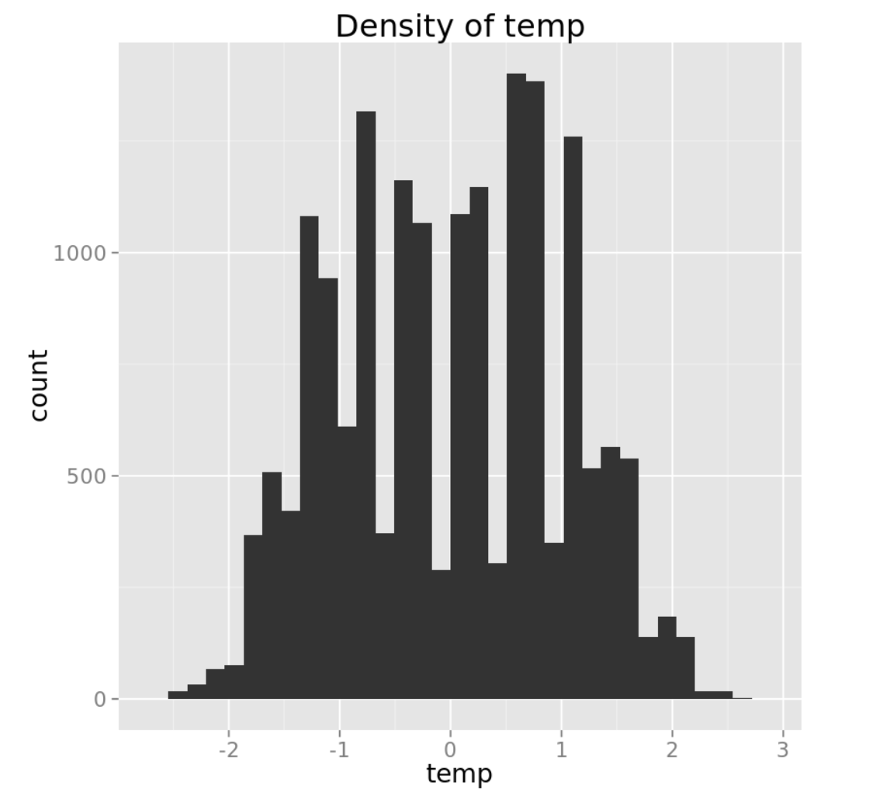

1. Review the other histograms, noting the density of the numeric features and the **cnt** label.
2. In an empty cell at the bottom of the notebook, enter the following code, and then run the new cell and wait for the code to finish running:

bike.hist.cond(dat, pltTimes)

1. View the histograms that are produced, which show the density of bike rentals conditioned by hour. Note that for some hours, there are multi-modal distributions that indicate that the number of bike rentals for each hours is not always consistent, and some other factors may be involved. For example, the plot below shows two clear peaks for bike rentals at 6:00am – at this time of day there are commonly around 25-30 rentals, or 100-125 rentals.

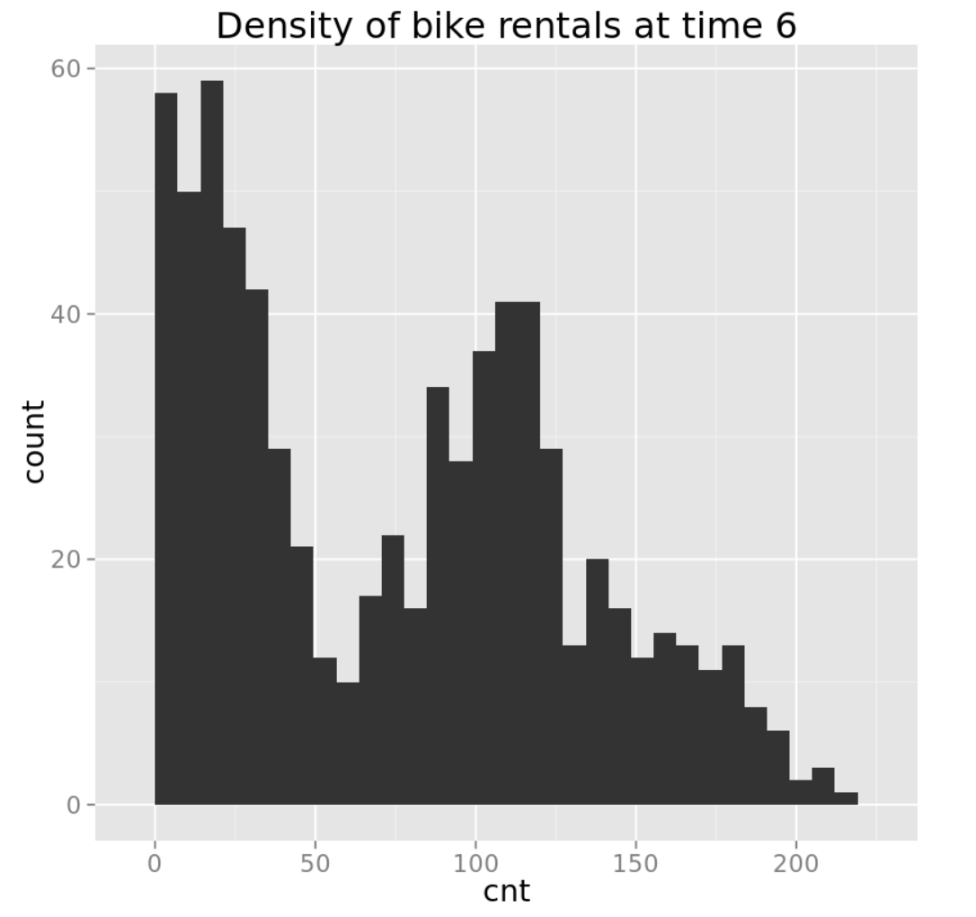

1. Review the other histograms, noting the distribution of bike rentals for each hour.
2. Save the notebook and return to the Azure ML experiment.

### Visualize the Data Using Python

1. Add a **Convert to CSV** module to the experiment and connect the output of the **Normalize Data** module to its input. Then run the experiment.
2. Right-click the output of the **Convert to CSV** module and in the **Open in a new workbook** submenu, click **Python 2**.
3. In the new browser tab that opens, at the top of the page, rename the new workbook **Bike Rental Visualization**.
4. Review the code that has been generated automatically. The code in the first cell loads a data frame from your experiment. The code in the second cell displays the data frame in the console.
5. On the **Cell** menu, click **Run All** to run all of the cells in the notebook, and then view the output.
6. On the **Insert** menu, click **Insert Cell Below** to add a new cell to the notebook.
7. In the new cell, enter the following code (which you can copy and paste from **BikeVisualize.py**):

num_cols = ["temp", "hum", "windspeed", "hr"]

def bike_scatter(df, cols):

import matplotlib.pyplot as plt

import statsmodels.nonparametric.smoothers_lowess as lw

## Loop over the columns and create the scatter plots

for col in cols:

## first compute a lowess fit to the data

los = lw.lowess(df['cnt'], df[col], frac = 0.3)

## Now make the plots

fig = plt.figure(figsize=(8, 6))

fig.clf()

ax = fig.gca()

df.plot(kind = 'scatter', x = col, y = 'cnt', ax = ax, alpha = 0.05)

plt.plot(los[:, 0], los[:, 1], axes = ax, color = 'red')

ax.set_xlabel(col)

ax.set_ylabel('Number of bikes')

ax.set_title('Number of bikes vs. ' + col)

return 'Done'

cat_cols = ['season', 'yr', 'mnth', 'hr', 'holiday',

'workingday', 'weathersit', 'dayOfWeek']

def bike_box(df, cols):

import matplotlib.pyplot as plt

## Loop over the columns and create the box plots

for col in cols:

fig = plt.figure(figsize=(8, 6))

fig.clf()

ax = fig.gca()

df.boxplot(column = 'cnt', by = col, ax = ax)

ax.set_xlabel(col)

ax.set_ylabel('Number of bikes')

ax.set_title('Number of bikes vs. ' + col)

return 'Done'

plt_times = [6, 8, 10, 12, 14, 16, 18, 20]

def bike_series(df, tms):

import matplotlib.pyplot as plt

lims = (min(df.cnt), max(df.cnt))

for t in tms:

fig = plt.figure(figsize=(8, 6))

fig.clf()

ax = fig.gca()

df[df.hr == t].plot(kind = 'line', x = 'days', y = 'cnt',

ylim = lims, ax = ax)

plt.xlabel("Days from start")

plt.ylabel("Bikes rented")

plt.title("Bikes rented by day for hour = " + str(t))

return 'Done'

hist_cols = ["cnt", "temp", "hum", "windspeed"]

def bike_hist(df, cols):

import matplotlib.pyplot as plt

## Loop over columns and plot histograms

for col in cols:

fig = plt.figure(figsize=(8, 6))

fig.clf()

ax = fig.gca()

df[col].hist(bins = 30, ax = ax)

ax.set_xlabel(col)

ax.set_ylabel('Density of ' + col)

ax.set_title('Density of ' + col)

return 'Done'

def bike_hist_cond(df, col, by):

import matplotlib.pyplot as plt

df = df[df.hr.isin(by)]

## Plot conditioned histograms

fig = plt.figure(figsize=(10, 8))

ax = fig.gca()

df[[col, 'hr']].hist(bins = 30, by = ['hr'], ax = ax)

return 'Done'

This code defines some functions that you will use to create plots of the data.

1. Ensure that the cursor is in the cell containing the function definitions above, and then on the **Cell** menu, click **Run and Select Below** (or click the ⯈ button on the toolbar).
2. After the code has finished running, in the new empty cell at the bottom of the notebook, enter the following code, and then run the new cell and wait for the code to finish running:

bike_scatter(frame, num_cols)

**Tip**: The code may take a few minutes to run. While it is running, a⏺symbol is displayed at the top right under the Python logo, and when the code had finished running this changes to a **O** symbol

1. View the plots that are produced.

**Tip**: Click the grey bar on the left edge of the output pane containing the plots to see all of the output in the main notebook window.

1. In the first two scatter plots (shown below), note that the number of bike rentals rises as temperature (**temp**) rises. Conversely, bike rentals tend to drop as humidity (**hum**) rises.

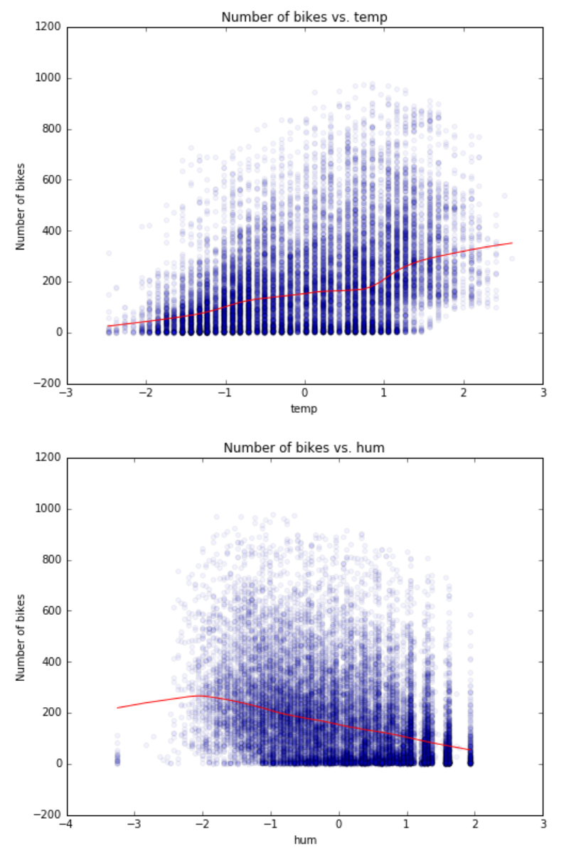

1. Review the other scatterplots, noting the apparent effect (or lack thereof) that the numeric features appear to have on the number of bike rentals.
2. In an empty cell at the bottom of the notebook, enter the following code, and then run the new cell and wait for the code to finish running:

bike_box(frame, cat_cols)

1. View the boxplots that are produced, which include the two boxplots shown below. Note that there are significant differences in bike rental demand by hour of the day (**hr**) – Most rentals occurring during commute hours, and very few rentals in the early hours of the morning. However, the day of the week (**dayOfWeek**) appears to make little difference to the number of bike rentals. Sunday has the lowest median, but the difference is well within the range of the middle two quartiles.

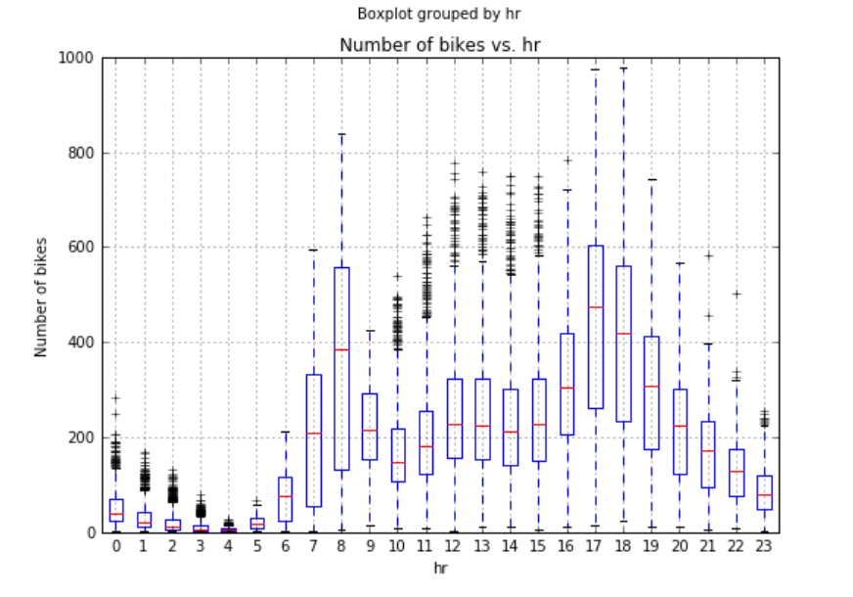

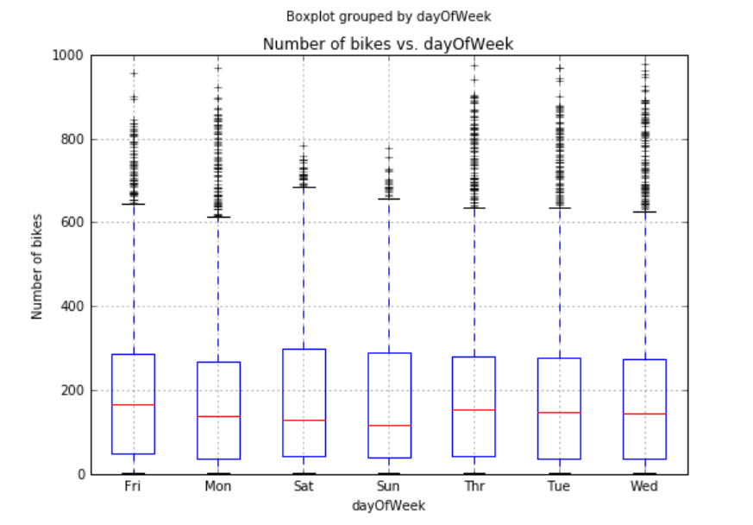

1. Review the other boxplots, noting the apparent effect (or lack thereof) that the categorical features appear to have on the number of bike rentals.
2. In an empty cell at the bottom of the notebook, enter the following code, and then run the new cell and wait for the code to finish running:

bike_series(frame, plt_times)

1. View the line plots that are produced, which include the two plots shown below. Note that there is a general trend of increasing bike rentals over time (**days**) for all hours of the day, and that the number of rentals at certain hours (for example hour 6, which is 6:00am) is consistently lower than for other hours (for example hour 18, which is 6:00pm). Further, there is a strong seasonal effect, where bike demand is strongest in the warm summer months. The daily variation in bike demand by hour of the day results in the high-frequency behavior observed.

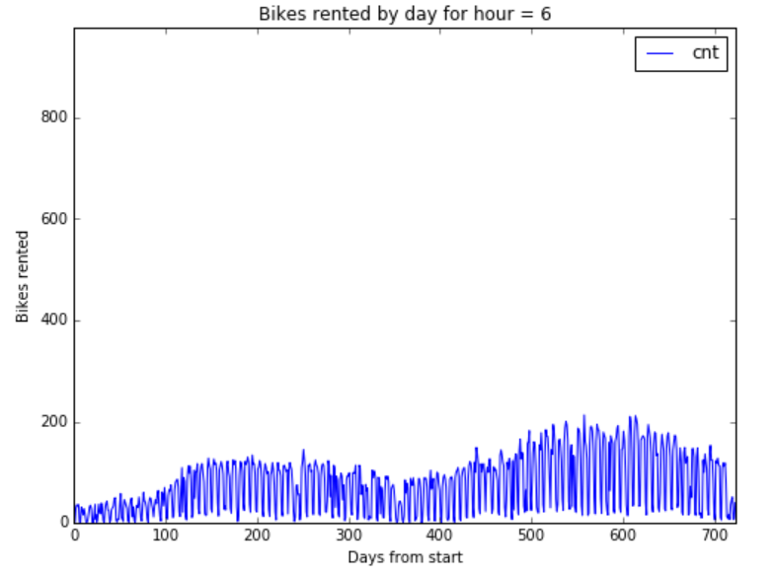

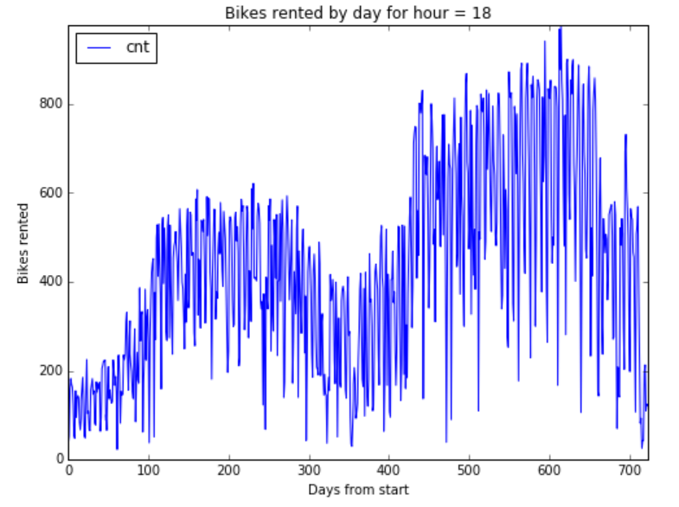

1. Review the other line plots, noting the trends for bike rentals at each hour of the day.
2. In an empty cell at the bottom of the notebook, enter the following code, and then run the new cell and wait for the code to finish running:

bike_hist(frame, hist_cols)

1. View the histograms that are produced, which include the plot shown below. Note that the normalized temperature values tend to most commonly be between -1 and +1, indicating that there are only a few occasions with extreme low or high temperatures.

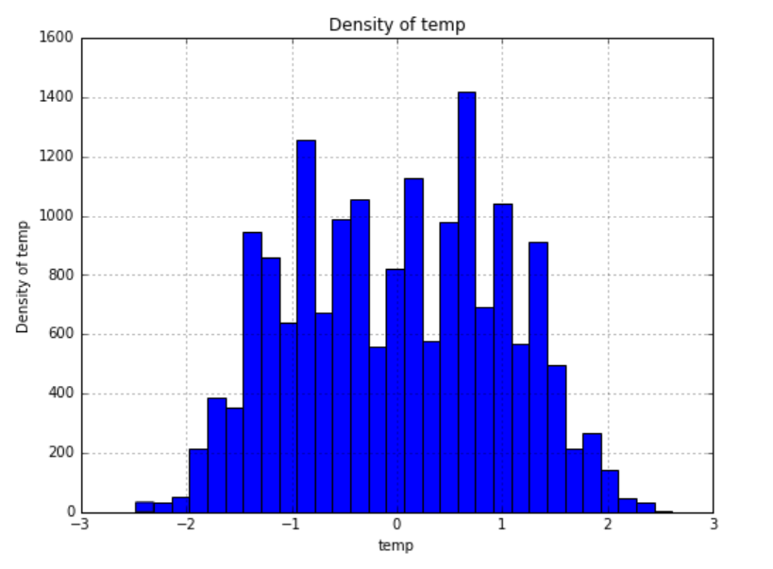

1. Review the other histograms, noting the density of the numeric features and the **cnt** label.
2. In an empty cell at the bottom of the notebook, enter the following code, and then run the new cell and wait for the code to finish running:

bike_hist_cond(frame, 'cnt', plt_times)

1. View the histograms that are produced, which show the density of bike rentals conditioned by hour. Note that for some hours, there are multi-modal distributions that indicate that the number of bike rentals for each hours is not always consistent, and some other factors may be involved. For example, the plot below shows two peaks for bike rentals at 6:00am – at this time of day there are commonly around 25-30 rentals, or 100-125 rentals.

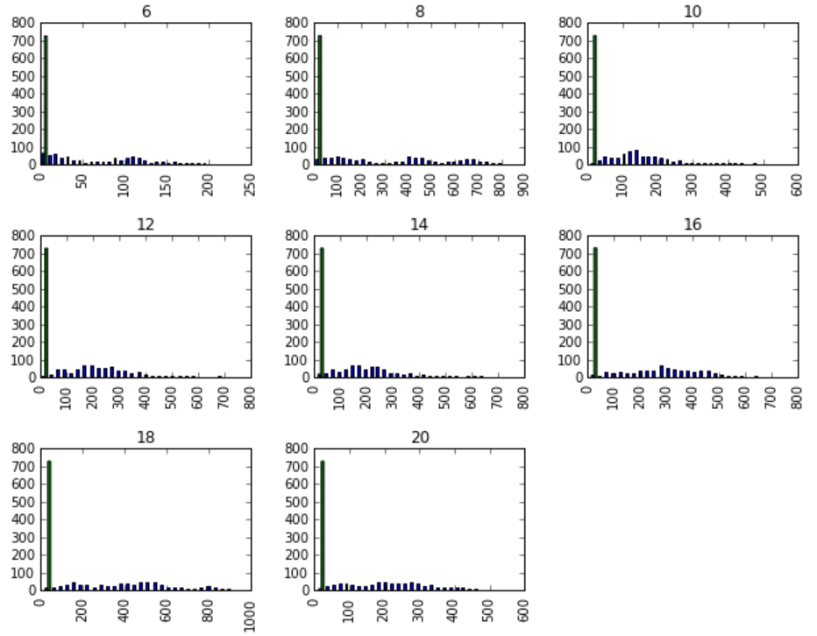

1. Save the notebook and return to the Azure ML experiment.

# Creating and Evaluating a Regression Model

Now that you have explored the data, you are ready to create a regression model.

## Create a Regression Model

1. Add a **Split Data** module to the experiment, and connect the output of the **Normalize Data** module to its input (bypassing the conversion to CSV, which was only required to load the data into a Jupyter notebook).
2. Set the properties of the **Split Data** module as follows:
   * **Splitting Mode**: Split Rows
   * **Fraction of rows in the first output dataset**: 0.7
   * **Randomized split**: Selected
   * **Random seed**: 123
   * **Stratified split**: False
3. Add a **Linear Regression** module to the experiment and place it next to the **Split Data** module. Then set its properties as follows:
   * **Solution method**: Ordinary Least Squares
   * **L2 regularization weight**: 0.001
   * **Include intercept term**: Not selected
   * **Random number seed**: 123
   * **Allow unknown levels in categorical features**: Selected
4. Add a **Train Model** module to the experiment; and connect the output of the **Linear Regression** module to its left input, and the left output of the **Split Data** module to its right input. Then configure its properties to select the **cnt** column as the label column.
5. Add a **Score Model** module to the experiment and connect the output of the **Train Model** module to its left input, and the right output of the **Split Data** module to its right input.
6. Verify that the bottom half of your experiment looks like this:

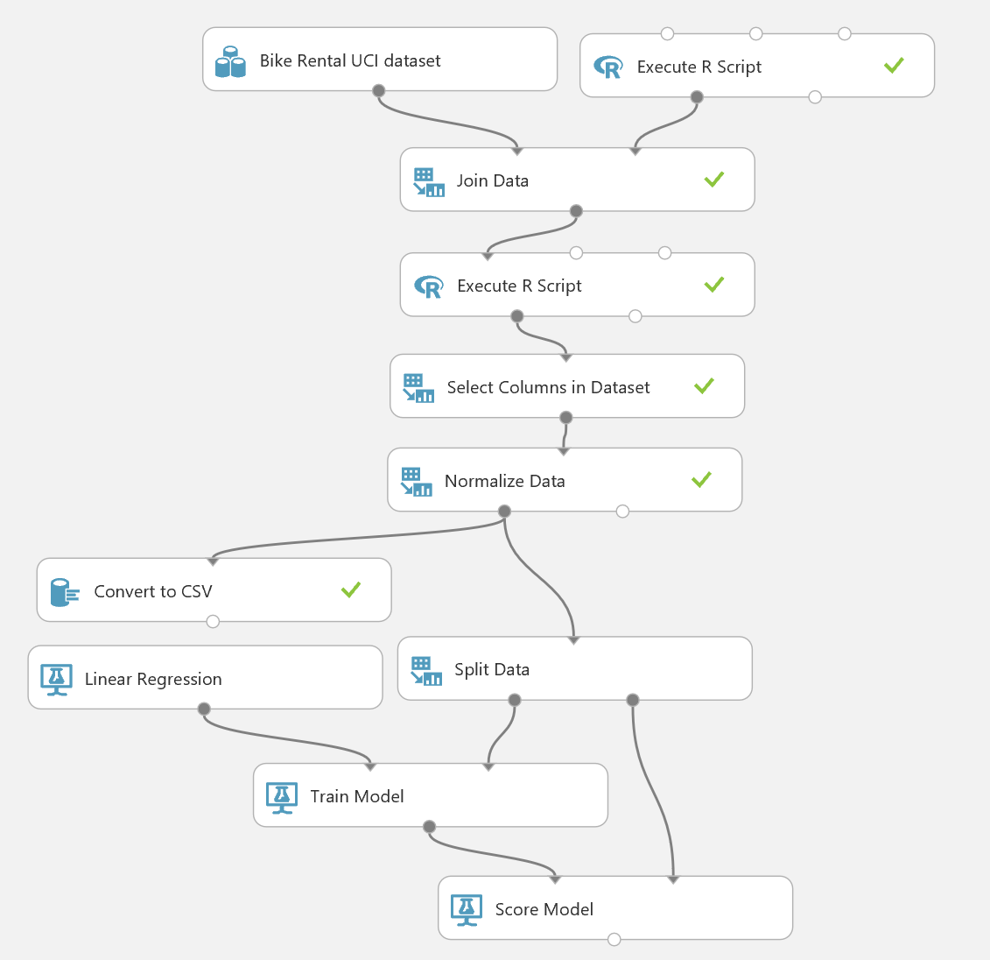

1. Save and run the experiment.
2. When the experiment has finished, visualize the output of the **Score Model** module and select the **Scored Labels** column. Then in the **Compare to** list, select **cnt** to view a scatterplot of the predicted labels against the actual known labels in the test data. This should resemble the following:

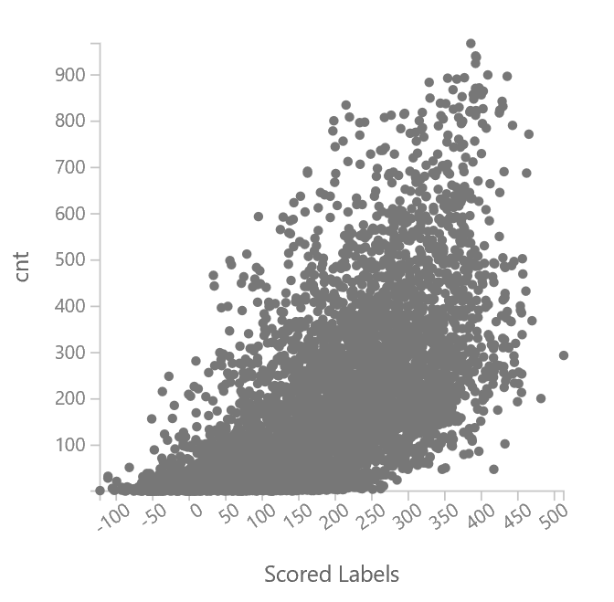

1. Note that the scatterplot shows a general diagonal line indicating some linear correlation between the predicted and actual label values. However, there are a large number of errors (or *residuals*) around this line, indicating that the model often fails to predict an accurate label value.

## Evaluate the Model

Now that you’ve created and scored a model, you can view some statistics and visualizations to evaluate its performance.

1. Add an **Evaluate Model** module to the experiment, and connect the output of the **Score Model** module to its left input. This built-in module provides common evaluation metrics that you can use to judge the performance of a model.
2. Save and run the experiment. Then, when the experiment has finished running, visualize the output of the **Evaluate Model** module and note the following:
   * The **Mean Absolute Error** and **Root Mean Squared Error** are metrics that estimate the accuracy of the model. They indicate the estimated number of bike rentals over or under the actual value the predicted label is. In this case, the values are quite high, and the model may predict a number of bike rentals that is over or under the actual amount by 100 or more.
   * The **Relative Absolute Error** and **Relative Squared Error** are higher than desirable – for an effective model, these should be around 0.1 or 0.2.
   * The **Coefficient of Determination** is a figure that represents the amount of variance that is explained by the model. For an effective model, this should be closer to 1 than to 0.

These metrics show that the model is not performing optimally, so you will now look at some visualizations to further explore the model’s performance. You can accomplish this with R or Python.

### Visualize Residuals with R

1. Add an **Edit Metadata** module to the experiment and connect the output of the **Score Model** module to its input.
2. Configure the properties of the **Edit Metadata** module as follows:
   * **Column**: Select the **Scored Labels** column
   * **Data type**: Unchanged
   * **Categorical**: Unchanged
   * **Fields**: Unchanged
   * **New column names**: predicted
3. Add an **Execute R Script** module to the experiment and connect the output from the **Edit Metadata** module to its left-most input.
4. Replace the default script in the **Execute R Script** module with the following code, which you can copy and paste from **BikeEvaluate.R** in the lab files folder for this module:

bikes<- maml.mapInputPort(1)

bikes[order(bikes$days, bikes$hr),]

## Time series plots showing actual and predicted values

times <- c(6, 8, 10, 12, 14, 16, 18, 20)

ts.bikes <- function(t, df){

require(ggplot2)

temp <- df[df$hr == t, ]

ggplot() +

geom_line(data = temp,

aes(x = days, y = cnt)) +

geom_line(data = temp,

aes(x = days, y = predicted), color = "red") +

ylab("Number of bikes rented") +

labs(title = paste("Bike demand at ",

as.character(t), ":00", spe ="")) +

theme(text = element_text(size=16))

}

lapply(times, ts.bikes, bikes)

## Compute the residuals

resids <- function(df){

library(dplyr)

df <- mutate(df, resids = predicted - cnt)

}

box.resids <- function(df){

## Plot the residuals by hour

require(ggplot2)

df <- resids(df)

df$fact.hr <- as.factor(df$hr)

print(str(df))

ggplot(df, aes(x = fact.hr, y = resids)) +

geom_boxplot( ) +

ggtitle("Residual of actual versus predicted bike demand by hour")

}

box.resids(bikes)

hist.resids <- function(t, df){

## Plot the residuals by hour

require(ggplot2)

df <- resids(df[df$hr == t, ])

print(str(df))

ggplot(df, aes(resids)) +

geom_histogram( ) +

ggtitle(paste("Histogram of residuals for hour =", as.character(t)))

}

lapply(times, hist.resids, bikes)

1. Ensure that the bottom half of your experiment looks like this, and then save and run it:

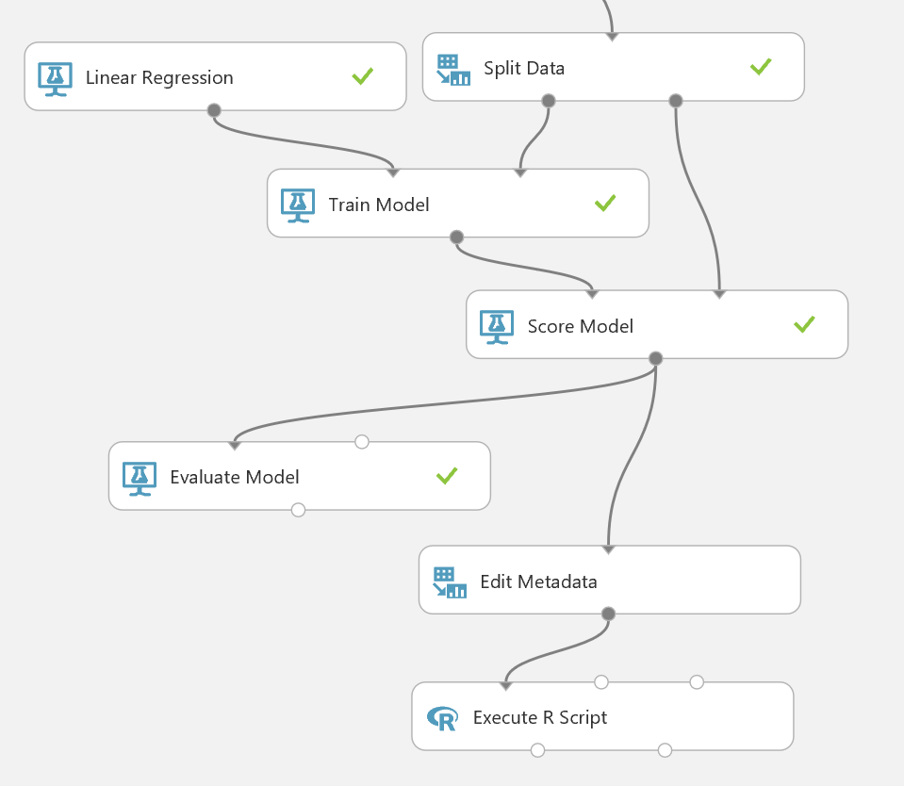

1. When the experiment has finished running, visualize the **R Device** (right) output of the **Execute R Script** module.
2. View the line plots, which show actual bike rentals in black, and predicted bike rentals in red for several hours of the day. In particular, note from the following plot that the model consistently underestimates the number of bike rentals at 8:00am:

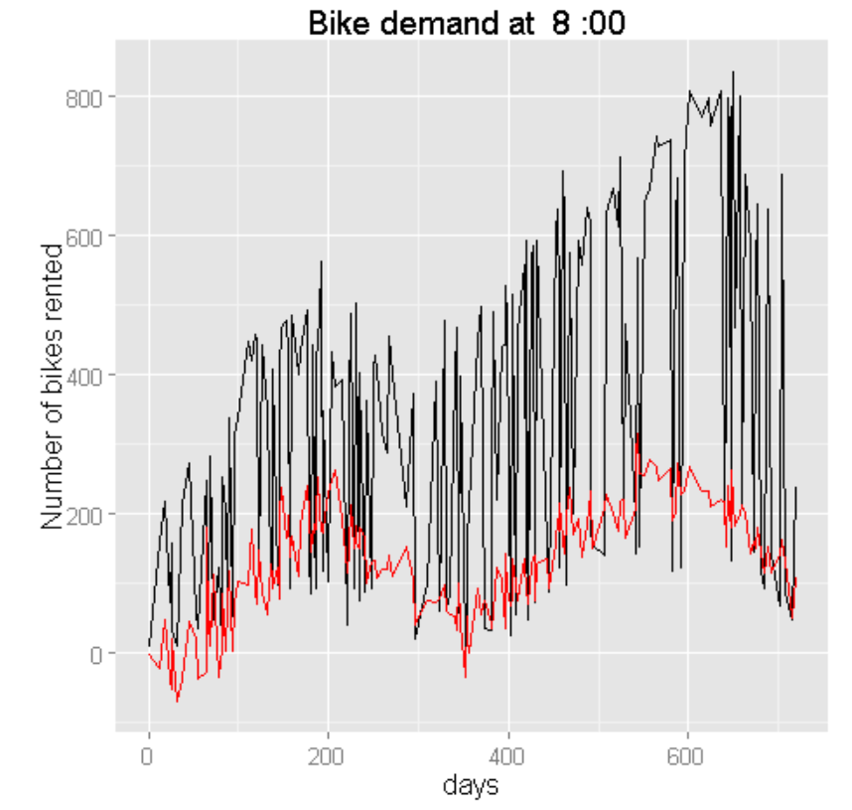

1. Note from the following boxplot that there are high negative residuals for the peak periods of bike rental in the day (around 8:00am and 6:00pm), confirming that the model is significantly under-predicting for these times.

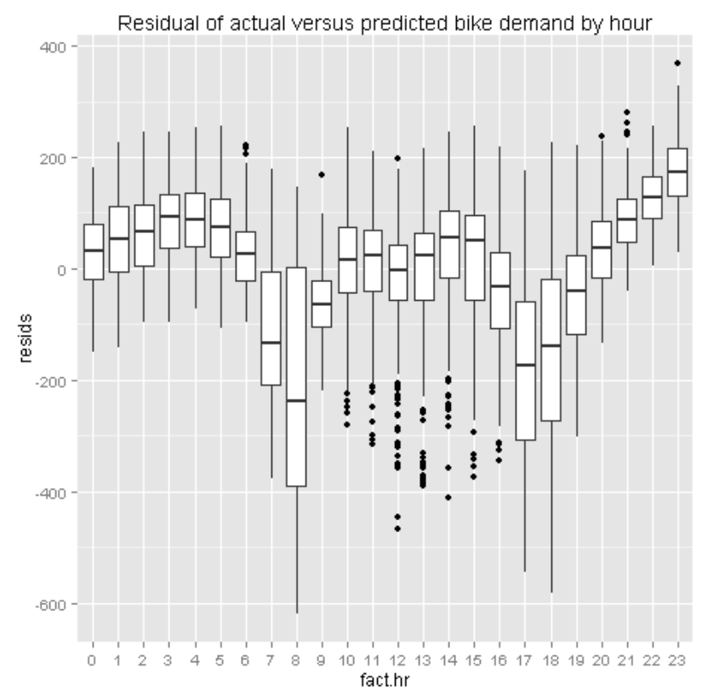

1. Review the histograms, and note that the distribution of residuals for 8:00am is multi-modal with several peaks. This, combined with the fact that you observed multi-modal distributions for bike rentals by hour earlier when exploring the data may indicate that the model is failing to capture some other aspect of hourly bike rental variance – perhaps the hourly patterns for working days is different from holidays and weekends:

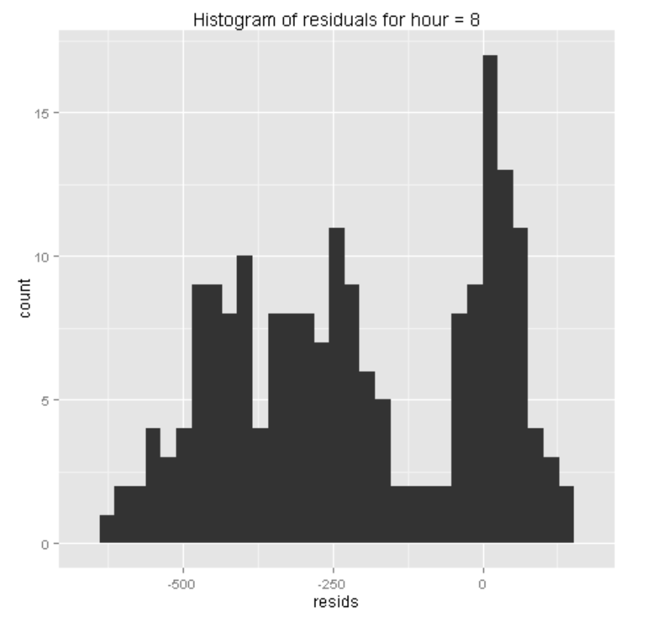

### Visualize Residuals with Python

1. Add an **Edit Metadata** module to the experiment and connect the output of the **Score Model** module to its input.
2. Configure the properties of the **Edit Metadata** module as follows:
   * **Column**: Select the **Scored Labels** column
   * **Data type**: Unchanged
   * **Categorical**: Unchanged
   * **Fields**: Unchanged
   * **New column names**: predicted
3. Add an **Execute Python Script** module to the experiment and connect the output from the **Edit Metadata** module to its left-most input.
4. Replace the default script in the **Execute Python Script** module with the following code, which you can copy and paste from **BikeEvaluate.py** in the lab files folder for this module:

def ts_bikes(df, times):

import matplotlib

matplotlib.use('agg') # Set backend

import matplotlib.pyplot as plt

for tm in times:

fig = plt.figure(figsize=(8, 6))

fig.clf()

ax = fig.gca()

df[df.hr == tm].plot(kind = 'line',

x = 'days', y = 'cnt', ax = ax)

df[df.hr == tm].plot(kind = 'line',

x = 'days', y = 'predicted', color = 'red', ax = ax)

plt.xlabel("Days from start")

plt.ylabel("Number of bikes rented")

plt.title("Bikes rented for hour = " + str(tm))

fig.savefig('ts_' + str(tm) + '.png')

return 'Done'

def resids(df):

df['resids'] = df.predicted - df.cnt

return df

def box_resids(df):

import matplotlib

matplotlib.use('agg') # Set backend

import matplotlib.pyplot as plt

df = resids(df)

fig = plt.figure(figsize=(12, 6))

fig.clf()

ax = fig.gca()

df.boxplot(column = ['resids'], by = ['hr'], ax = ax)

plt.xlabel('')

plt.ylabel('Residuals')

fig.savefig('boxes' + '.png')

return 'Done'

def ts_resids_hist(df, times):

import matplotlib

matplotlib.use('agg') # Set backend

import matplotlib.pyplot as plt

for tm in times:

fig = plt.figure(figsize=(8, 6))

fig.clf()

ax = fig.gca()

ax.hist(df.ix[df.hr == tm, 'resids'].as_matrix(), bins = 30)

plt.xlabel("Residuals")

plt.ylabel("Density")

plt.title("Histograms of residuals for hour = " + str(tm))

fig.savefig('hist_' + str(tm) + '.png')

return 'Done'

def azureml_main(df):

df = df.sort(['days', 'hr'], axis = 0, ascending = True)

times = [6, 8, 10, 12, 14, 16, 18, 20, 22]

ts_bikes(df, times)

box_resids(df)

ts_resids_hist(df, times)

return df

1. Ensure that the bottom half of your experiment looks like this, and then save and run it:

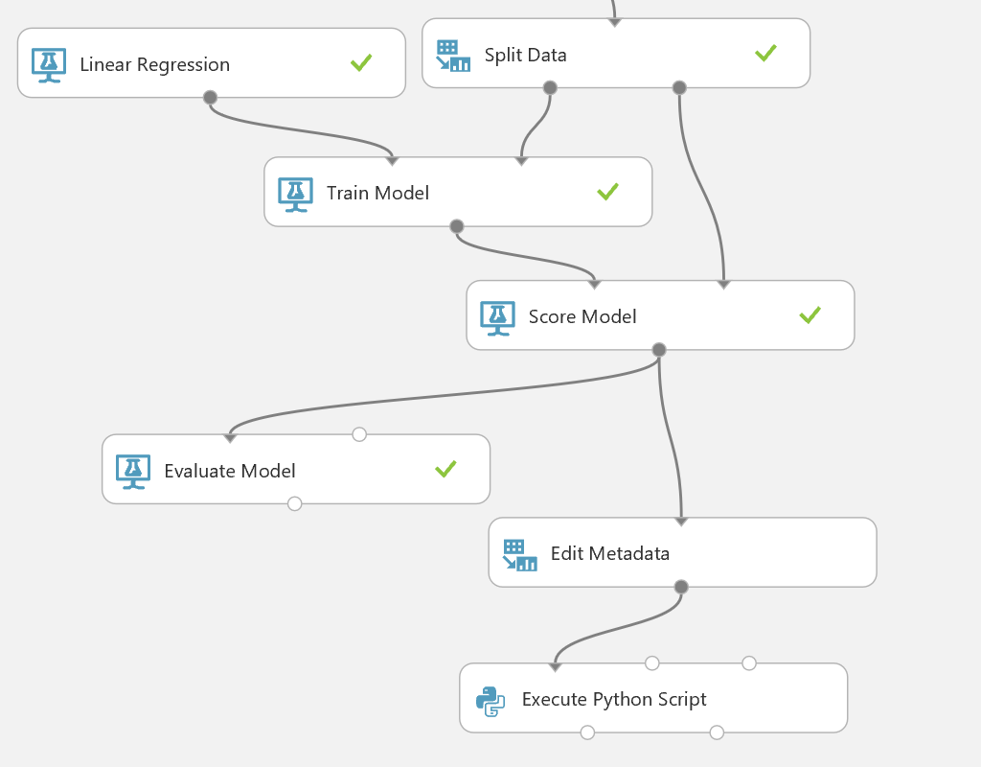

1. When the experiment has finished running, visualize the **Python Device** (right) output of the **Execute Python Script** module.
2. View the line plots, which show actual bike rentals in blue, and predicted bike rentals in red for several hours of the day. In particular, note from the following plot that the model consistently underestimates the number of bike rentals at 8:00am:

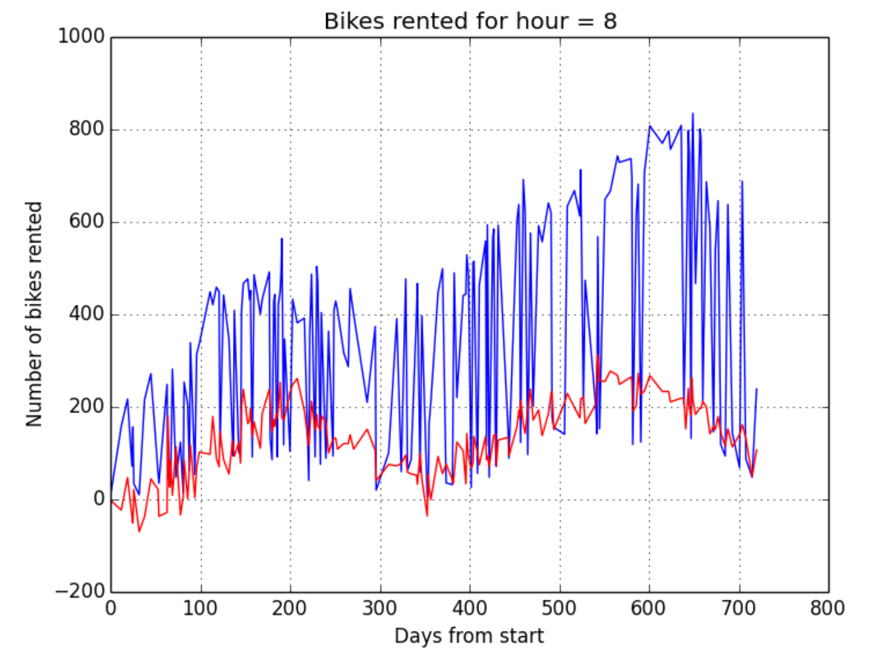

1. Note from the following boxplot that there are high negative residuals for the peak periods of bike rental in the day (around 8:00am and 6:00pm), confirming that the model is significantly under-predicting for these times.

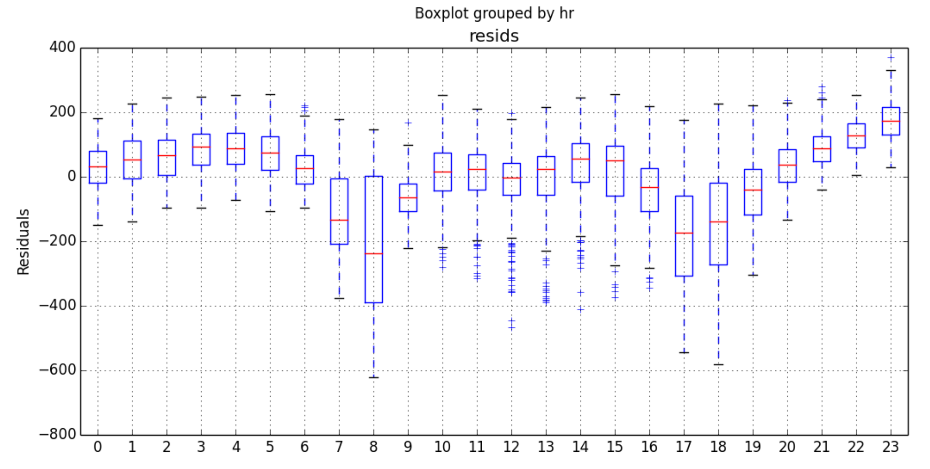

1. Review the histograms, and note that the distribution of residuals for 8:00am is multi-modal with several peaks. This, combined with the fact that you observed multi-modal distributions for bike rentals by hour earlier when exploring the data may indicate that the model is failing to capture some other aspect of hourly bike rental variance – perhaps the hourly patterns for working days is different from holidays and weekends:

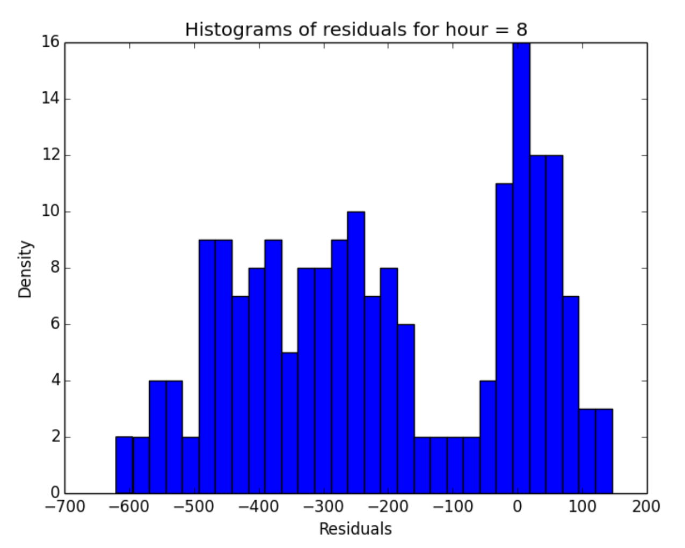

# Summary

In this lab, you have created and evaluated a regression model. The model shows potential, but requires significant improvement. You could start to improve the model by identifying and removing outliers, and exploring the idea that working day bike rental demand follows a different pattern to that of holidays and weekends (watch the demonstrations in the module for this lab to see an approach for doing this – the R and Python code files are provided in the lab folder, so you can try it for yourself if you feel like a challenge!)

Later modules in this course will discuss further model improvement techniques, which could be applied to this model in order to predict demand for rental bikes more accurately